Aim:
- To investigate the population size of a plant species using random sampling
- To investigate the effect of a factor on plant distribution using systematic sampling (a transect line)

Part 1 – Investigating the population size of a plant species using random sampling.
Equipment needed | Method | Precautions
If you have access to a field  - Quadrat  - Plant identification guide  - Clipboard  - Pen | - Mark out a known area in a field (e.g. 20 m by 20 m)  - Select random coordinates (e.g. using random number generator)  - Place a quadrat at the coordinates  - Count the number of organisms (e.g. the number of daisies) within the quadrat  - Repeat by placing the quadrat at the random coordinates, suggested 10 different coordinates  - Use the measurements to calculate a mean number of organisms per quadrat  - Estimate the size of the population using:  Estimated population size = (total area/area sampled) x mean number of organisms per quadrat  Note this is the same as calculating how many quadrats could fit in the total area and multiplying this by the average number of organisms found in the samples  Alternatively you can get pupils to count the number of different species in each quadrat. | Hayfever risk depending upon season – discuss this with students beforehand.  Follow usual school procedures for trips to ensure student safety.  CLEAPSS Student Safety Sheet – Fieldwork: SSS075
If you do not have access to a field  - Large format print-out of a daisy field (ideally of 1m length) – laminated  - 10cm by 10cm quadrat on printable transparency  - Plant identification guide | - Place the printed daisy field on the table (1m in this example)  - Select random coordinates to place the 10 cm by 10 cm quadrat template on.  - Count the numbers of daisies present in the quadrat each time.  - Repeat by placing the quadrat at the random coordinates, suggested 10 different coordinates  - Use the measurements to calculate a mean number of organisms per quadrat  - Estimate the size of the population using:  Estimated population size = (total area/area sampled) x mean number of organisms per quadrat | Templates for a daisy field and quadrats can be found online.  Make sure that they are laminated.

Part 2 – Investigating the effect of a factor on plant distribution using systematic sampling.
Equipment needed | Method |  | Precautions
If you have access to a field  - Quadrat  - 10m measuring tape  - Plant identification guide  - Clipboard  - Pen | - Lay out a tape measure on over a clear 10m of the field  - Place the quadrat on the ground at the 0 metres mark  - Count the number of organisms in the quadrat  - Move 2m further along the measuring tape and repeat the process (using quadrats at regular intervals of 2m) until you reach 10m  - If light intensity is the factor being investigated, a light meter can be used to measure the light intensity at each interval |  | Hayfever risk depending upon season – discuss this with students beforehand.  Follow usual school procedures for trips to ensure student safety.
If you do not have access to a field  - Large format print-out of a daisy field (ideally of 1m length) – laminated  - 10cm by 10cm quadrat on printable transparency  - Plant identification guide  - Ruler | - Place the printed daisy field on the table (1m in this example)  - Measure 20 cm intervals using a ruler and place the transect at the 0cm mark  - Count the numbers of quadrats with daisies present  - Move 20cm further along the ruler and repeat the process until you reach 1m |  | Templates for a daisy field and transects can be found in the folder.  Make sure that they are laminated.
Set up for practical outside  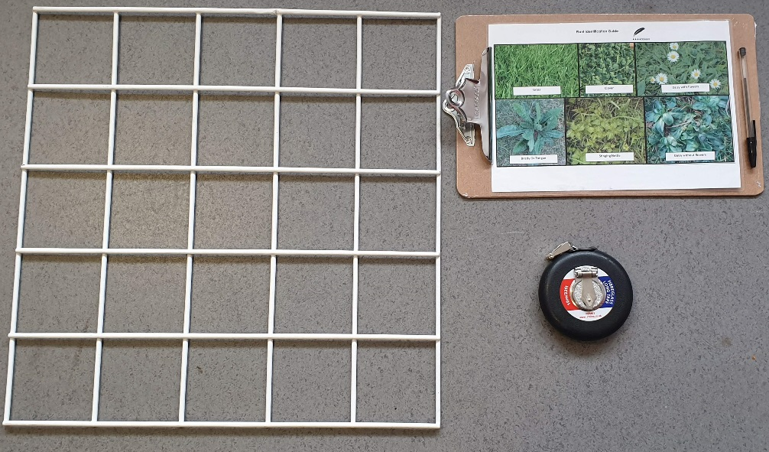 |  | Clear up  If you are taking your students out onto a field, count in and out all equipment that is being used to ensure that nothing is left behind.
General Teacher Notes

A risk assessment must to be completed for this practical. The risk assessment should be specific to the class involved and written only by the teaching member of staff. This may include additional risk assessment for taking students off the premises – check your school’s trips policy.
For more guidance refer to CLEAPSS
Technician Tips

This logistics of this practical depend upon what facilities you have near to your school. If you have access to a field, you need to know in advance which area your students should study. It is essential that the teacher does a risk assessment specifically for that area.

Taking additional members of staff is recommended to keep an eye on students in an open area.

If you are doing this inside, make sure that the printed daisy field sheet is laminated to prevent any rips.
Set up for practical inside

If the practical is being done inside, an example of a daisy field can be found in the folder under: grass-field-with-daisy-flowers-aerial-view.

This picture should be enlarged so that it is 1m long.

There is also a transect template made on Excel that can be printed off and laminated to be used as a makeshift transect.

